# **Overview**

* **About our team**
  + **Members and their roles:**
* 1. Kuanyshbek Sagyngaliyev (id: 201564; email: [201564@astanait.edu.kz](mailto:201564@astanait.edu.kz) ) is responsible for the organization and design of the website.
* 2. Sanzhar Kiyasov (id: 201997; email: [201997@astanait.edu.kz](mailto:201997@astanait.edu.kz) ) is responsible for the header, main page (except of social media part and footer), links and helped to organize header, footer section on other web pages.
* 3. Arman Shametov (id: 201608; email: [201608@astanait.edu.kz](mailto:201608@astanait.edu.kz) ) is responsible for the menu.
* 4. Arman Skezhanov (id: 201499; email: [201499@astanait.edu.kz](mailto:201499@astanait.edu.kz) ) is responsible for the footer and Mailchimp form.
* 5. Aida Sapenova (id: 201226; email: [201226@astanait.edu.kz](mailto:201226@astanait.edu.kz) ) is responsible for project documentation.
  + **Communication strategy**
* Tuesday 02.02.2021 the roles of each member of the group were assigned, the style of the site and its features were chosen.
* Thursday 04.02.2021 there was an assessment of each other's work and a discussion about where to correct.
* Saturday 06.02.2021 gluing parts of the site into one, checking for working capacity, adjustments and release of a full-fledged site.
* **Motivation**
* This project is needed to make it convenient for visitors to the AITU canteen to learn information about the menu and new products.
* Thanks to this project, it is possible to increase the level of service and digitalization within the university itself.
* With this project, you can save time on booking and receiving an order.
* **High-level project scope**

We took this site as an example: <https://plov.kz/> . Namely, in the menu tab, we made the same lift up when considering the ingredients that are included in it. Everything else was invented and developed by us.

* **Target audience/market**

The website is focused entirely on AITU staff, students and guests.

# **Project goals and team interests**

Project goals

* Convenient browsing of menus and establishments
* Clarity of information about various new products
* Improving the quality of service to the target audience

Team interests

* Developing HTML and CSS skills
* Adapting and improving teamwork skills
* A clear understanding of the principles of website design

# **Phases**

* Phase 1 – Basic website dedicated to AITU University cafeteria menu with HTML (currently)
* Phase 2 – Enhanced functionality to improve usability and reach a wider audience
* Phase 3 – Incorporating a shopping cart into the site to organize online shopping and improve the online reservation form

# **Content structure**

**Site map**

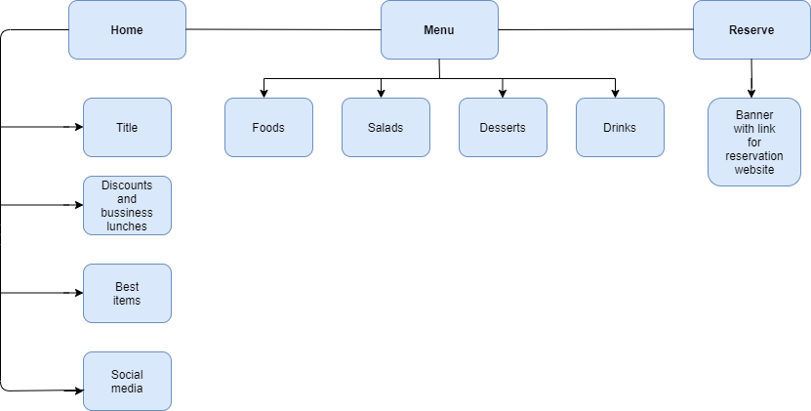

**Content types**

* Home
* Menu
* Reserve

**Design**

* Reference links: [Freepik.com](http://freepik.com/), [Unsplash.com](http://unsplash.com/) and Adobe Photoshop
* Image files: http: [images](http://tiny.cc/imagesofproject)
* Sketch files: no sketch files
* Colours: dark blue (#21243d), salomie color (#ffd17e), black (#111111), white (#ffffff)
* Typography rules: for titles - bold type, weight – 700, for text - regular type, weight - 400
* Hover states: we decided to hover only the text, not full button, since when we hover some button, it may spoil the design of page. During the hover, there changes only text color with its bright or dark type
* Animations: we used simple animations like zoom-out and scroll-up
* Grid systems: we divided the page by headings and menu was created using CSS Grid. In the beginning, we wanted to divide our pages into sections with different backgrounds. However, it did not look like we wanted, that is why we decided to choose identical background with different figures
* Spacing: there is no specific spacing we just declared it according to background and sections

**Functionality**

Everything on the webpages is simple to understand and some specific things which we can notice that we used images on the main page as a link to some parts of a menu page. In a menu page we used grid system to make well organized menu section.

First of all, we built and designed a form via MailChimp, after that, in the reservation webpage we added a button which leads to this form. All data that we collect from the form goes to audience in MailChimp account.

We used bootstrap to make our code simple and shorter. It as also necessary to have advanced kind of objects in our website. Also, MailChimp is one of the examples of API, we made our code in order to avoid creating database for form.

**Hosting**

We uploaded all our files on the GitHub repositories – saved it – went to the settings and in GitHub pages section we selected brunch as a main and changed folder from docs to root until the link of our website did not work.

**Accessibility**

Unfortunately, our site is not adapted for people with disabilities. At the same time, we believe that our site is organized simply and easily understood by users. In our website there are no problems with the readability of texts and transitions between pages. Therefore, we believe that we have done a good job of making the website accessible.

**Deadlines**

* Phase 1 – February 7, 23:59
* Phase 2 – February 10, 15:00
* Phase 3 – February 15, 21:00

# **Summary**

Canteen is a site dedicated to all visitors to the AITU canteen. The site has all the necessary inclusions to get acquainted with the menu, new products and even has a reservation section. During the execution of this site, everyone worked together as a team and clearly performed their duties. We can say that, we have achieved the goals of the project and the interests of our team, but we realized that, we still have a lot to learn, because we faced considerable problems with lifting up the column with the description and price of the dish on the menu, it was also difficult to make response on mobile phones, so we did not have quite the site as we would like, but despite all this, we learned a lot of new things. For example, how to work with Bootstrap, how to create a Mailchimp form, edit by page placement, how to add and link tabs, etc. We think that for the first project in teamwork we did very well, and we hope that you will appreciate the website at its true worth.